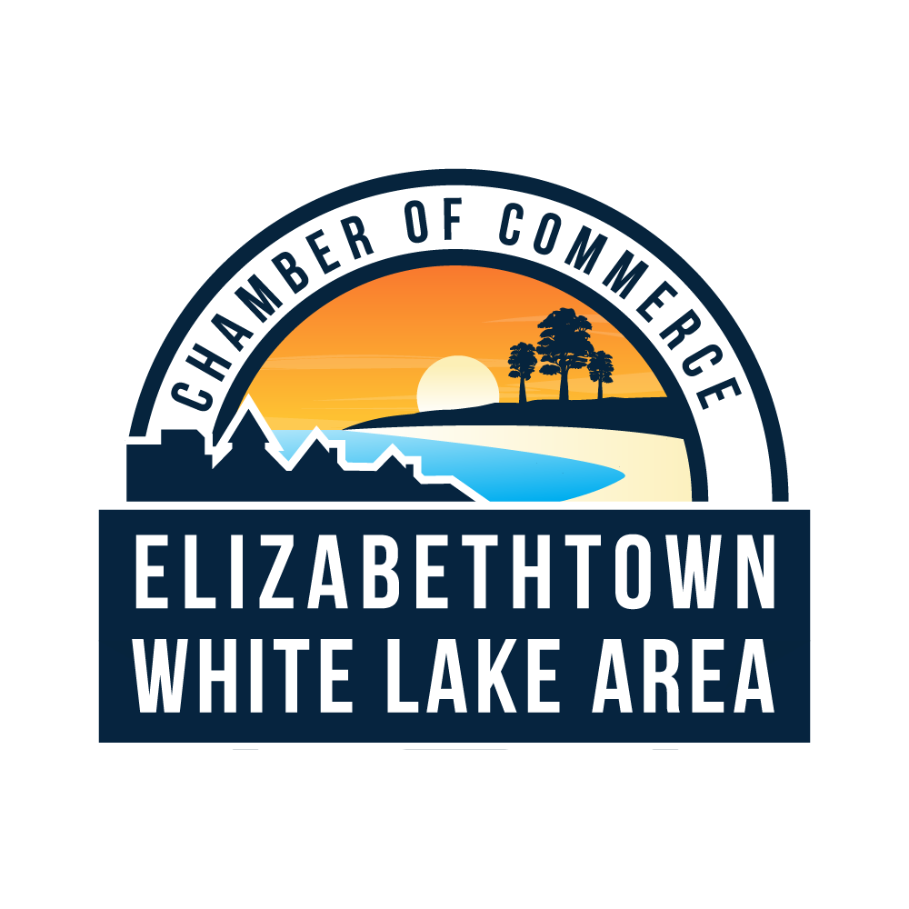
The Elizabethtown-White Lake Area Chamber of Commerce
Award Recipients

Outstanding Chamber Member of the Year Award
1999-2000 Larry Barnhart
2000-2001 Donna G. Payne
2001-2002 David Smitherman
2002-2003 James R. Melvin
2003-2004 D.M. (Mac) Campbell
2004-2005 Sherry K. McCulloch
2005-2006 Elaine Lomax
2006-2007 Dr. Norfleet Midyette
2007-2008 Denise T. Bridgers
2009-2010 Robin Summerlin
2011 Thompson, Price, Scott & Adams
2012 Till & Butler, CPAs
2013 Scott Walters
2014 Dan Allen
2015 Alan Maynard
2016 Town of White Lake
2017 Fisher’s Mens & The Ladies Shop
2018 Town of Elizabethtown
2019 Whimsical Florist & Gifts
2020 Barefoot Brew
2021 Faith Partner Christian Supply
Bookstore
2022 Camp Clearwater
2023 Campbell Oil

Outstanding Small Businessperson of the Year Award
1994 D.M. (Mac) Campbell
1995 Robert M Summerlin III
1996 Lee Greene & Hobby Greene
1997 Ron Taylor
1998 Floyd Merritt
1999 Walter Bullard
2000 Henson Barnes
2001 David Shaw
2002 A.D. Tolar
2003 Bruce Dickerson
2004 Powell Cross
2005 Carl deAndrade
2006 Elizabethtown Veterinary Hospital
2007 Dorman Motors
2008 Barking Lot
2009 Richard Allen
2010 Robert Hester, Bladen Online
2011 A Shelter Friend
2012 Vanessa G. Photography
2013 Giorgio’s Restaurant
2014 Tim Blount
2015 Ricky Leinwand
2016 Whimsical Florist
2017 June Massengill, Cape Fear BBQ & Chicken
2018-Susan & Ronald Inman, Regal Resort & The Venue
2019 McDuffie Pest Control
2020 Alex Munroe, Cape Fear Winery / Cape Fear Distillery
2021 Dean Hilton, Hilton Realty/ Grand Regal
2022 Michael & Gina Burney, Burney’s Sweets & More
2023 Bo & Kelly Barefoot, Barefoot Sandwich Shop, Barefoot Brew & Barefoot Boujee Boutique

Caring Person of the Year Award
(This award can be given to a citizen in the community and is not limited to members.)
1995 Arthur Watkins
1996 Julie Adee
1997 Ecwood (Woody) C. Lancaster III
1998 Joan Marion
1999 Harvey Bedsole
2000 Naomi Miller
2001 Sylvia Campbell
2002Dale Brennan
2003 Jim Cole
2004 Rev. Dr. Bill Young
2005 Mark Gillespie
2006 Ann H. Nye
2007 Danny Adkins
2008 Cathy Page
2009 Jim Cole
2010 Minnie Price
2011 Dr. Gensel
2012 Tiina Mundy
2013 David Clark
2014 Faye Womble
2015 Walter Bullard
2016 Bobby Lewis (Posthumously)
2017 Barbara Knight & Ann Garrett, United Way
2018 Chris Clark
2019 Bruce Dickerson
2020 Dr. Teresa Duncan, Bladen County Health Director
2021 Anne Warner, Bladen We Care
2022 David DeAndrade, White Lake Marine
2023 Greg Brinson, Cape Fear SORBA

Honorary Lifetime Chamber Membership Award
2004 Roy Jessup
2010 H. Manly Clark Jr,
2011 Hubert Kinlaw
2012 Wallace Leinwand
2013 Mac Campbell Jr.
2014 Carl deAndrade
2015 Harry Womble
2016 Robert Hester
2017 Mary Greene, Greene Lake and Conservation Park
2018 Dr. William Findt
2019 Charles Ray Peterson
2020 Lee Greene, Bladen Builders Supply
2021 Sylvia Campbell
2022 Ron Taylor
2023 Dr. Douglas Genzel, Elizabethtown Veterinary Hopsital

LEGACY AWARD – started in Jan. 2021
2020 Eddie Madden, Elizabethtown Town Manager
2021 Brenda Clark, retired, Town of White Lake
2022 Sondra Guyton, Bladen Community College
2023 Greg Martin, Bladen County Manager

